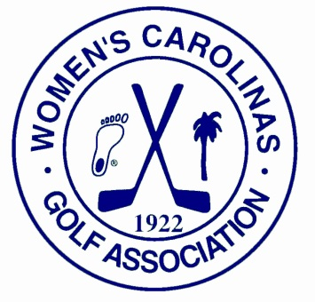
Women’s Carolinas Golf Association
Conveys to the Carolinas Golf Association

We are pleased to announce an exciting future for women golfers in the Carolinas. Effective July 31, 2012, all of the services provided by the Women’s Carolinas Golf Association will transfer to the Carolinas Golf Association.
The Women’s Carolinas Golf Association was founded in 1922 to conduct what has become the oldest and most widely acclaimed women’s golf championship in the Carolinas.
The Women's Carolinas Golf Association has been a major force in contributing to the advancement of women's golf in both North Carolina and South Carolina. Through their sponsorships of junior girls' golf and the Women’s Carolinas/Virginias team matches, the association encouraged a high level of play for women amateurs of all ages. In recent years, there have been many challenges facing this all volunteer organization, not the least being the constantly advancing internet technology.
After careful consideration and recognizing the professional excellence of the Carolinas Golf Association, the WCGA board voted unanimously to transfer the competition schedule to the CGA. The WCGA assets will be transferred to the CGA’s general fund. The future Carolinas Golf House will house the WCGA archives and newly restored Championship trophy.
The Women’s Carolinas Championship was first played in 1923 and remains the only three-day stroke play championship for women of the Carolinas. Next year, the 87th Women’s Carolinas Championship will be played as scheduled at Treyburn Country Club in Durham, NC, May 20-23, 2013. The Championship format will not change.
The WCGA Junior Girls' Championship for the youngest players will also remain on the schedule and in the capable hands of Vicki DiSantis and her excellent crew of volunteers. We are committed to providing this special opportunity for the youngest girls of the Carolinas to have a positive tournament learning experience.
The Women’s Carolinas/Virginias Team Matches also transitions to the CGA. The captains will alternate between North and South Carolina. This competition versus the Virginias team began in 1957 and continues to celebrate the best in team spirit.
The current Board of Directors of the Women’s Carolinas Golf Association would like to give special thanks to the hundreds of women who have volunteered their time in the 90 year history of this association. Thanks is also due to the golf clubs and women’s associations who have provided financial support throughout the years. And of course, thanks to the women golfers of every age and skill level who have competed in the WCGA events. We are certain that the Carolinas Golf Association will carry on these great traditions.

WCGA Board of Directors
Kim Clarke, President

